


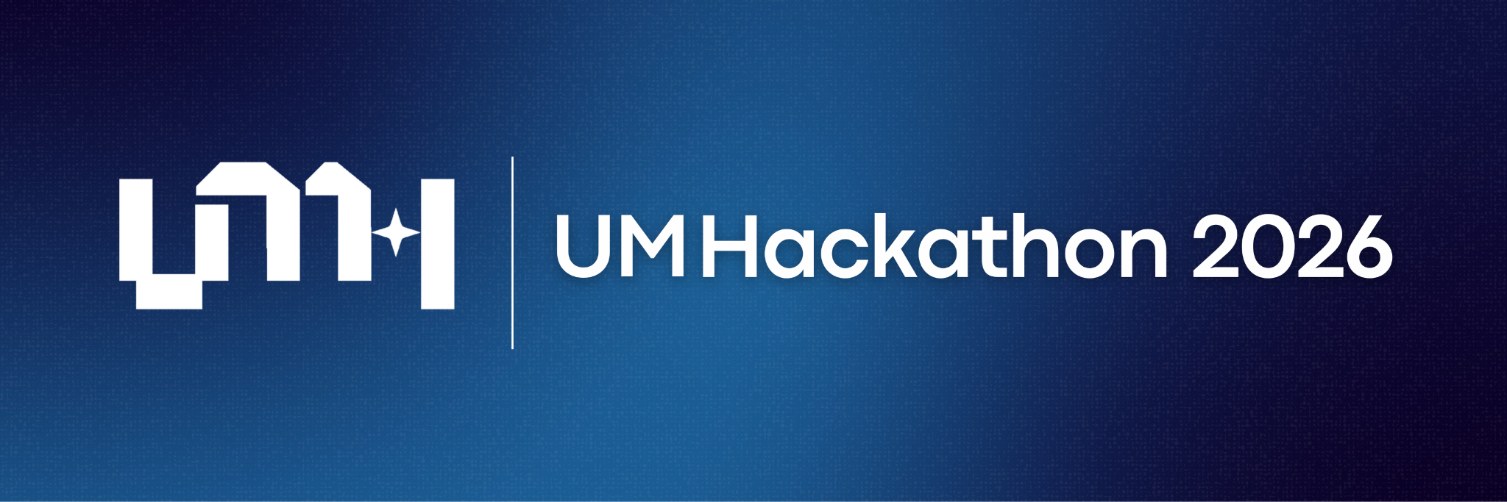

____________________________________

Frequently Asked Questions

UMHackathon 2026 Frequently Asked Questions (FAQ)

- What is UMHackathon 2026?
UMHackathon 2026 is a national-level hackathon organised by the Persatuan Komputer Universiti Malaya (PEKOM), featuring a two-part structure where teams first participate remotely in an online Preliminary Round from 16 April 2026 to 27 April 2026 (including judging period) to tackle defined challenges, with the top 30 teams then qualifying for the final round from 28 April 2026 to 3 May 2026. The event is committed to providing a high-quality experience through strategic collaborations with leading technology corporations to secure valuable resources, expert mentorship, and corporate sponsorship, all intended to elevate the quality of the event and the participants' experience.

- Can participants join UMHackathon 2026 individually or in teams?
Participants have the option to join individually or in teams.

- How many members are allowed in a group for UMHackathon 2026?
Teams may comprise a minimum of one (1) and a maximum of five (5) members.

- How many participants can join the UMHackathon 2026?
There is no limit to the number of participants for UMHackathon 2026.

- How many teams are allowed to participate in UMHackathon 2026?
There is no limit to the number of teams allowed to join the preliminary rounds, and only the top 30 teams will proceed to the final round.

- Can I change my team members after registration?
Once the registration has been made, you are not allowed to change your team members.

- Can I still register for UMHackathon 2026 if I cannot find any teammates?
You can access our Discord channel to find teammates, or you can choose to register individually. The QR code on our Instagram page will direct you to our Discord server. You may find your potential teammates through the Teammate Finder Sheets.
- Is participation limited to only students enrolled in computer science? Can I invite friends from other faculties and universities?
Participation in UMHackathon 2026 is open to all active students enrolled in a registered and recognised tertiary institution, not just those majoring in computer science. You are encouraged to invite friends from different faculties or universities, regardless of their field of study or year of study, to team up and compete in UMHackathon 2026.

- Do participants need to pay for the registration?
Yes, each team of UMHackathon 2026 has to pay a commitment fee of RM50, which will be duly refunded after the team has submitted their materials for the preliminary round.

- How do participants register for UMHackathon 2026?
Each team will elect a leader and fill in the UMHackathon 2026 Team Registration Form. A formal acceptance notice will be sent to the team leader via email upon valid team registration.

- When to register for UMHackathon 2026?
The registration form will open from 16:00:00, 20 February 2026, to 15:59:59, 16 April 2026 (UTC+8).

- What is the mode of execution for UMHackathon 2026?
The UMHackathon 2026 will be divided into two rounds: the preliminary round and the final round. The domains and problem statements for the preliminary round will be announced on 16 April 2026 (Thursday), at 20:00:00. An online meeting will be held to explain the domain and how each team is assigned to their domain and problem statement. All teams may start to build their prototype once they receive their problem statement. The preliminary round will be carried out from 16 April 2026 (Thursday), at 21:00:00 until 26 April 2026 (Sunday), at 07:59:59. Consequently, there will be a judging period on the 27 April 2026.

The final round of UMHackathon 2026 will be held from 28 April 2026 to 3 May 2026. Key events, such as the opening ceremony, workshops, final pitching, and closing ceremony, will take place over these six days. For the last two days, namely 2 May 2026 and 3 May 2026, UMHackathon 2026 will take place physically, and the location of which will be updated soon.

- Will these sessions and workshops be conducted online or physically?
All sessions/workshops in the UMHackathon 2026 will be conducted ONLINE. Only participants who qualify for the final round are required to attend physically on 2 May 2026 and 3 May 2026.

- Are the sessions and workshops recorded?
Yes, all sessions and workshops will be recorded.

- Is it compulsory to involve all team members in the final pitching presentation?
No, it is not obligatory to include all team members in the final pitching presentation. However, delivering a dynamic, clear, concise, and convincing presentation is essential for achieving high scores in the judging criteria, particularly in the preliminary round. For more information, please refer to the Judging Criteria.

- Can we observe other teams’ presentations during the pitching session?
Participants must remain in the waiting room before and after their pitching session, as presentations are private between teams and domain judges. So, participants are not allowed to observe the other team’s performance or presentation.

- How many teams are selected as winners from each domain?
At least the top three (3) teams from each domain will be announced as winners.

- Can we choose the domain on our own?
Participants are not allowed to choose their domain, as the domain selection for each team will be determined randomly through a luck-based draw system.

- Is food provided throughout the physical dates of the final round?
Yes, we will provide light snacks for all participants throughout the physical dates of the final round of UMHackathon 2026.

- Where will the hackathon occur, and is it mandatory for participants to stay at the venue the whole time?
The hackathon will occur tentatively at Auditorium Kompleks Perdana Siswa (KPS), Universiti Malaya, tentatively. All participants must stay at the venue throughout the event for safety purposes.

- Will accommodation be provided throughout the event?
Yes, accommodation will be provided. All the participants will stay at the assigned places in Auditorium Kompleks Perdana Siswa (KPS), Universiti Malaya. However, participants are required to bring their extensions, sleeping bags, sleeping items, personal items, and other items deemed needed by participants, as those are not provided by the organising committee of UMHackathon 2026.

- Will transportation be provided throughout the event?
No, transportation will not be provided; all participants must cover their travel expenses to the venue. However, we will supply a detailed roadmap to assist you in navigating to our venue, Auditorium Kompleks Perdana Siswa (KPS), Universiti Malaya.

- Is there a dress code requirement for UMHackathon 2026?
Participants are advised to wear smart casual attire during the event, but formal wear is compulsory for the final pitching.

- Is there a WiFi connection available at the event location?
Yes, a WiFi connection will be available during the hackathon to ensure that all the participants can work efficiently. However, it’s recommended for participants to have their own data plan in case of emergencies.

- Are the services provided (cloud, database, et cetera) free for a certain period of time or for the duration of the whole program?
No, unfortunately, cloud services will not be provided.

- Will there be mentors provided to guide participants throughout the hackathon?
Yes, mentors will be provided to guide participants during working hours between 18 April 2026 to 25 April 2026 and 2 May 2026.

- Are datasets provided for participants? If so, are they mandatory to use, or can participants utilise their own datasets?
No, datasets will not be provided. Participants are recommended to use the Domain-Specific folder to follow for updated guidelines.

- Is there any specific knowledge or programming language required for participation?
Participants can utilise any programming language with which they are comfortable. However, participants should possess familiarity with pertinent technologies and tools essential for constructing functional and deployable applications. The suggested solution or MVP (Minimum Viable Product) should showcase a comprehensive utilisation of these technologies and tools, effectively meeting all product functionalities.
- What should be submitted by each team?
For the preliminary round, participants are required to produce a prototype, which they must submit together with their documentation materials and presentation deck/slides for the recorded pitching session along with the pitch deck. Participants are also required to include a link to their source code (e.g. GitHub repository) to help judges gain deeper insights into the project’s technical implementation. Participants who proceed to the final round are required to produce an MVP (Minimum Viable Product), and submit their pitching slides, other submission materials and GitHub URL of the source code through the link provided by the UMHackathon 2026 Organiser.

- Will certificates be provided to participants for their participation in the hackathon?
E-certificates will be emailed to the team leader for teams that successfully submit their source code and complete the initial pitching.

- Who should we contact for further queries?
For enquiries, kindly reach out to us via email at umhackathon@um.edu.my or through the Discord Server.

